**Western Governors University (WGU)**

**Data Mining II – D212**

**Task 1: Clustering Techniques**

**Natallia Zimnitskaya | ID: 012247127**

**Master of Science, Data Analytics**

**Part I:**

**A. 1.** The purpose of this data mining report is to analyze patient data to identify groups of patients with similar characteristics, enabling the hospital to make informed business and strategic decisions. By understanding the demographics and behavior patterns of patients, the hospital can better tailor treatments, improve patient care, and optimize resource allocation.

**Research Question:** How can the hospital segment its patient population based on age and total charges to identify groups with similar characteristics that influence hospital admissions and healthcare costs?

**A. 2.** A goal of this analysis is to identify distinct groups of patients based on their age and total hospital charges, which will enable the hospital to tailor treatment plans, improve patient care, and optimize resource allocation effectively.

This goal is reasonable and within the scope of the selected scenario as it directly uses the available data (Age and TotalCharge) to understand patient characteristics. By achieving this goal, the hospital can:

* Enhance Patient Care: By recognizing distinct patient groups, the hospital can customize treatments and interventions for specific clusters.
* Optimize Resources: Allocate resources more effectively by understanding the needs and characteristics of different patient groups.
* Reduce Costs: Identify high-cost patient groups and develop strategies to manage and reduce these costs, ensuring long-term cost-effectiveness.

**Part II: Technique Justification**

**B. 1.** K-means clustering is an unsupervised learning method that groups similar data points into clusters (Sharma, 2024). This technique works by assigning each data point to the nearest centroid, which represents the average value of the data points within a cluster. The primary goal is to ensure that data points within the same cluster are highly similar to each other, while those in different clusters are as distinct as possible. The expected outcome of applying K-means clustering to a dataset is the segmentation of data into an optimal number of clusters, which can be determined using various evaluation metrics like the silhouette score or inertia. These metrics help assess the quality and coherence of the clusters formed.

**B. 2.** K-means clustering assumes that all clusters have equal variance (GeeksforGeeks, 2023). This means that each cluster has a similar spread of data points around its center. When this assumption holds true, the algorithm effectively groups the data into distinct clusters. However, if clusters have different variances, K-means might not accurately capture the data structure, leading to less reliable clustering results. It's important to consider this assumption because datasets with varying cluster variances may need different clustering methods for better accuracy.

**B. 3.** Here is the list of packages or libraries I've chosen for Python:

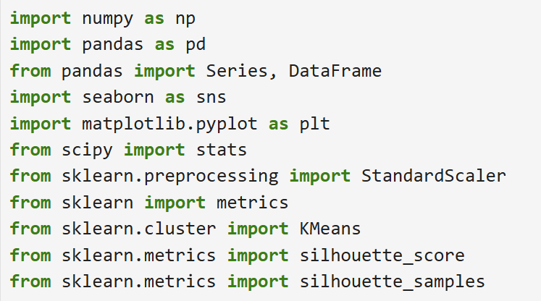

* **NumPy** provides support for large multi-dimensional arrays and matrices, along with a collection of mathematical functions to operate on these arrays. It's essential for numerical computations and data manipulation.
* **Pandas** is crucial for data manipulation and analysis. It offers data structures like **Series** and **DataFrame** to handle and manipulate structured data effectively, allowing for easy data cleaning, merging, and transformation.
* **Seaborn** is a visualization library based on Matplotlib that provides a high-level interface for drawing attractive statistical graphics. It simplifies the creation of complex visualizations, making it easier to understand patterns and distributions in the data.
* **Matplotlib** is a comprehensive library for creating static, animated, and interactive visualizations. It's widely used for plotting and visualizing data, providing tools to customize and enhance plots for better data interpretation.
* **SciPy** builds on NumPy to provide additional functionality for scientific and technical computing. The **`stats`** module in SciPy is particularly useful for statistical analysis and hypothesis testing, which are essential for data analysis.
* **Scikit-learn** includes various classification, regression, clustering algorithms, and tools for model evaluation and selection, making it a go-to library for machine learning practitioners.
* **StandardScaler** standardizes features by removing the mean and scaling to unit variance. This preprocessing step ensures that all features contribute equally to the clustering algorithm.
* **Metrics** provides various tools and functions for evaluating the performance of machine learning models, including clustering algorithms.
* **Silhouette Score** measures the quality of the clusters by calculating how similar each data point is to its own cluster compared to other clusters, helping assess cluster cohesion and separation.
* **Silhouette Samples** calculates the silhouette coefficient for each individual data point, providing a detailed view of how well each point fits within its assigned cluster.
* **KMeans** is the core clustering algorithm used in the analysis. It partitions the data into clusters based on the nearest mean, helping identify groups with similar characteristics.

These packages collectively support the entire data analysis pipeline, from data manipulation and visualization to clustering and model evaluation, ensuring a comprehensive and effective analysis.

**Part III: Data Preparation**

**C. 1.** A key data preprocessing goal relevant to the K-means clustering technique is the standardization of continuous variables, specifically Age and TotalCharge. K-means clustering relies on Euclidean distance to assign data points to clusters, making it sensitive to the scale of the variables. If the features are not standardized, those with larger ranges can dominate the distance calculations, leading to biased clustering results. Standardizing these variables ensures they contribute equally to the clustering process by transforming them to have a mean of zero and a standard deviation of one. This step improves the accuracy of the K-means algorithm, allowing it to define clusters based on the inherent patterns in the data rather than the scale of the features. Implementing standardization using the StandardScaler from the sklearn.preprocessing module ensures that the K-means algorithm performs optimally, leading to more accurate and reliable clustering outcomes.

**C. 2.** For the scope of the current analysis, the focus will be on continuous variables only:

* **Age** represents the age of the patients. It is a continuous variable since it can take any numerical value within a range.
* **TotalCharge** represents the amount charged to the patient daily. This value reflects an average per patient based on the total charge divided by the number of days hospitalized, excluding specialized treatments.

By using these continuous variables, we aim to identify distinct groups of patients based on their age and daily hospital charges, which will help in understanding and improving patient management strategies.

**C. 3.** Data Preparation Steps:

* Import essential Python libraries for data manipulation, visualization, and clustering analysis.

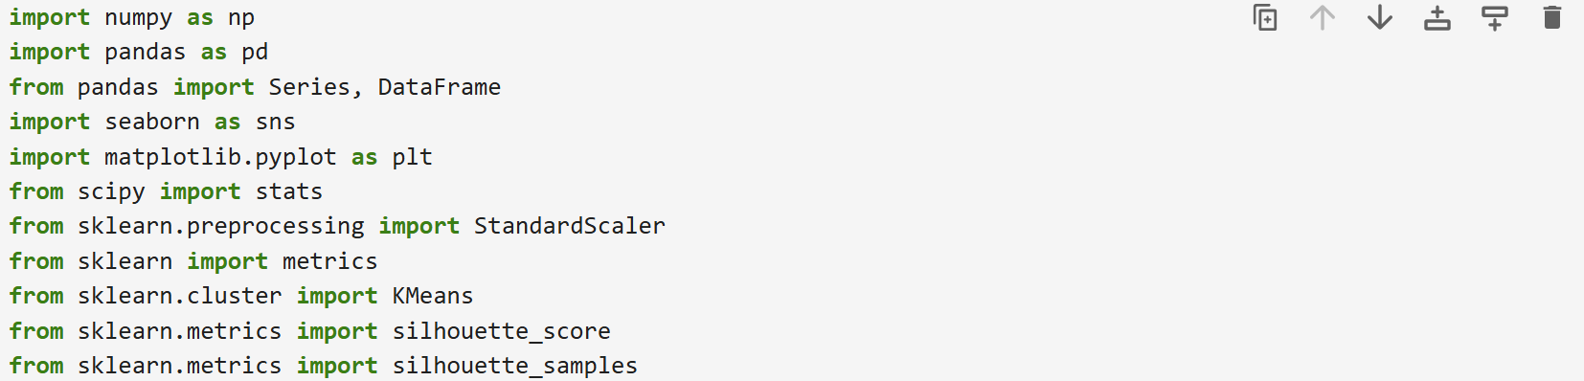

* Read the dataset into a dataframe for analysis and get the dataset information.

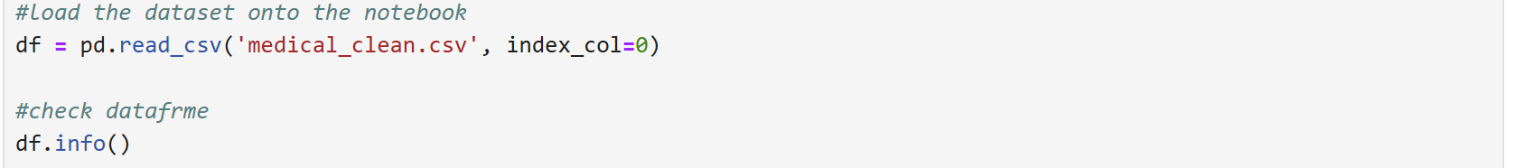

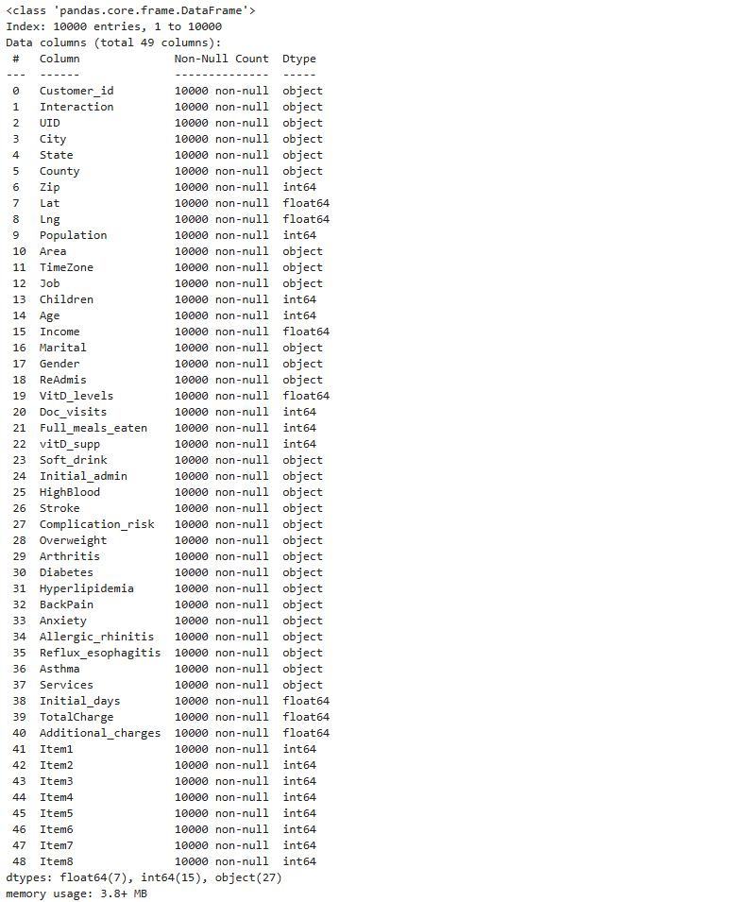

* Visually inspect the dataframe to facilitate exploration and identify any initial issues.



* Define and select the continuous variables relevant to the task.

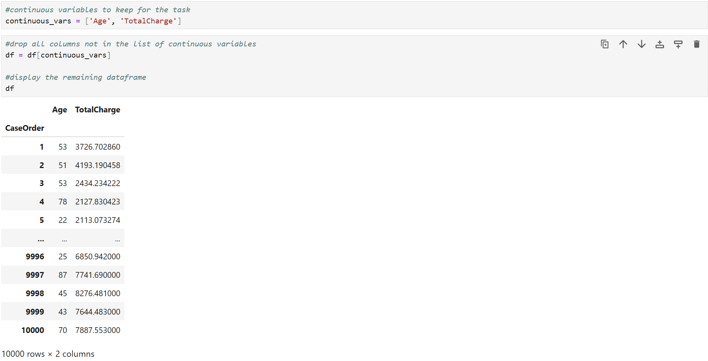

* Identify and count any duplicate rows in the dataframe.

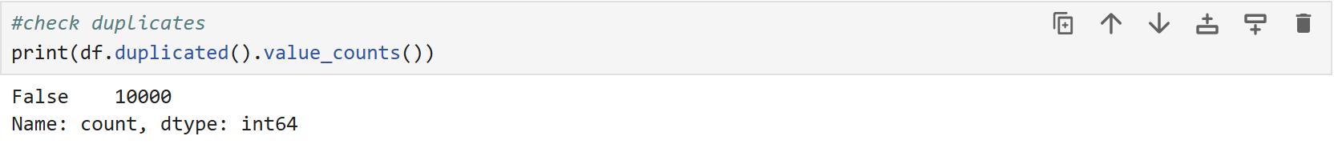

* Identify and sum any missing values in the dataframe.

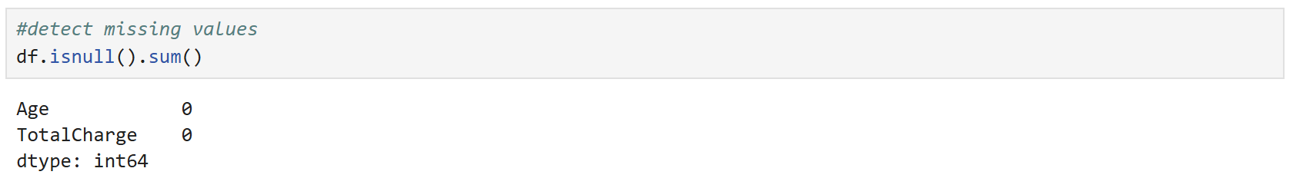

* Identify and remove outliers using the z-score method.

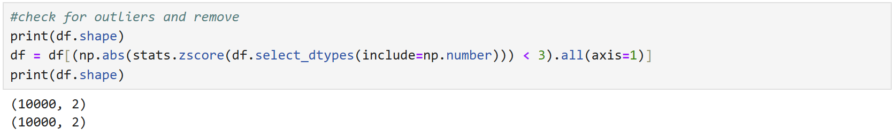

* Create histograms to visualize the distribution of continuous variables.

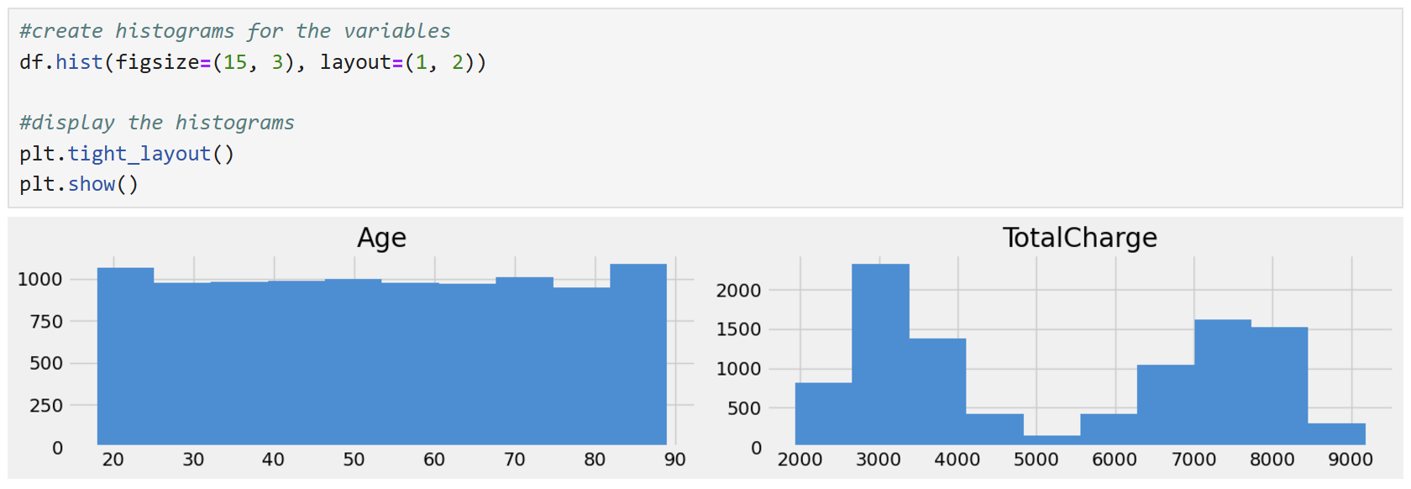

* Create boxplots to visually inspect the distribution and detect any remaining outliers.

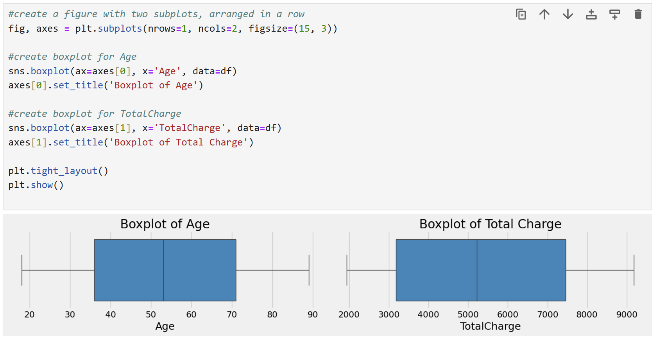

* Get descriptive statistics for Age and TotalCharge.

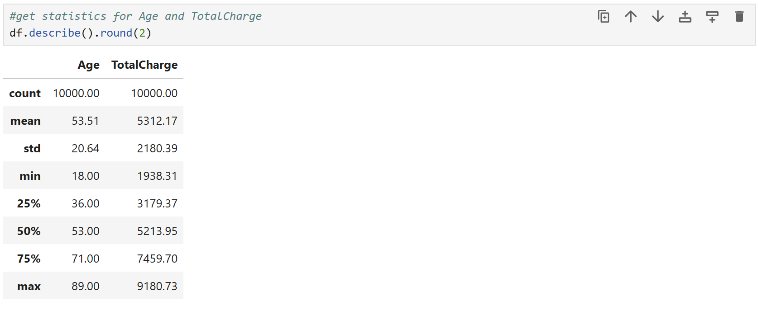

* Visualize the relationship between Age and TotalCharge to see if there are any visible clusters.

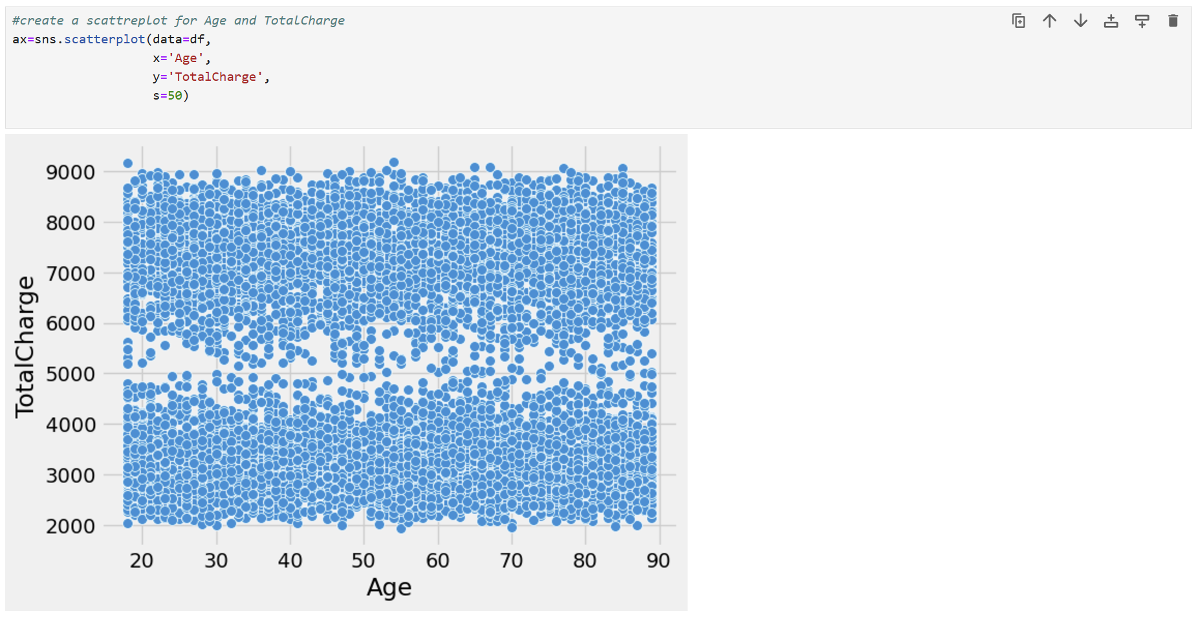

* Standardize the continuous variables to ensure equal contribution to the clustering process.

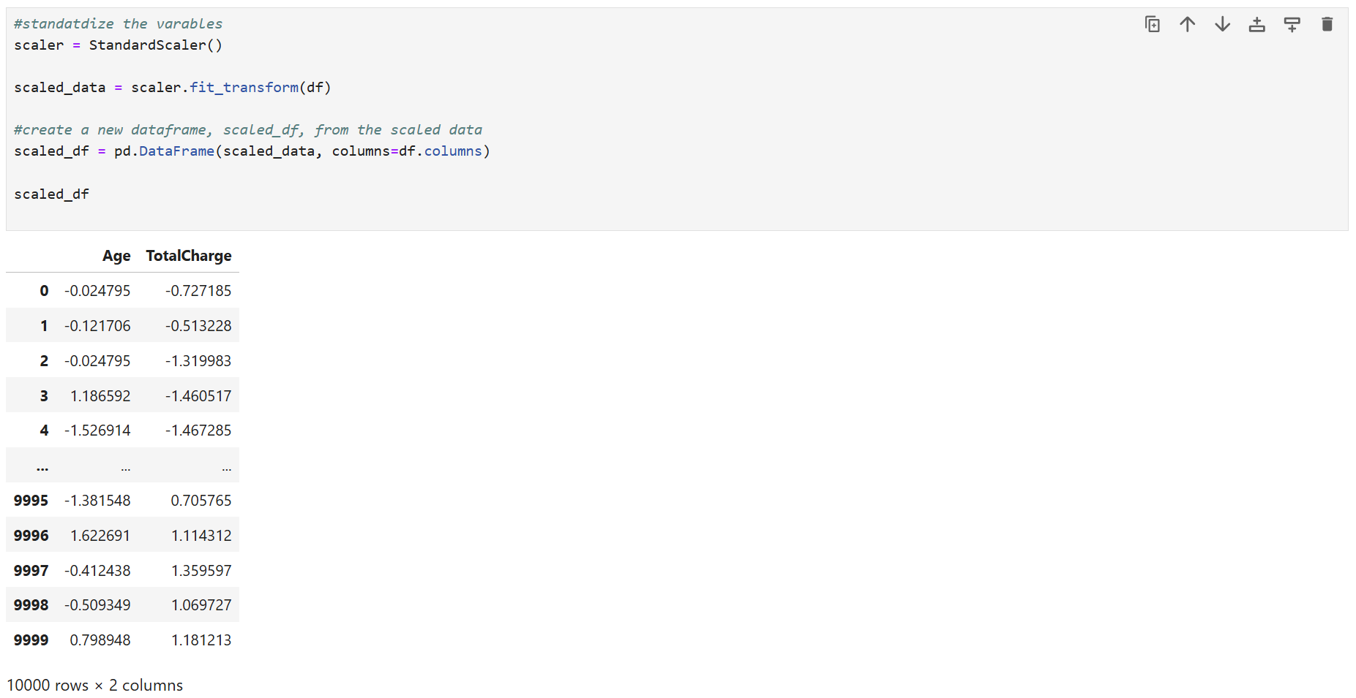

* Save the cleaned and standardized datasets to CSV files for future use.

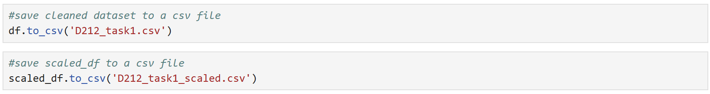

**C. 4.** Files containing the cleaned dataset “D212_task1.csv” and the standardized dataset “D212_task1_scaled.csv” are attached to this submission.

**Part IV: Analysis**

**D. 1.** Method for Determining the Optimal Number of Clusters:

1. Initial K-Means Clustering:

* Step: Perform an initial K-means clustering with k=2.
* Reason: The initial scatterplot suggests the presence of two distinct clusters.

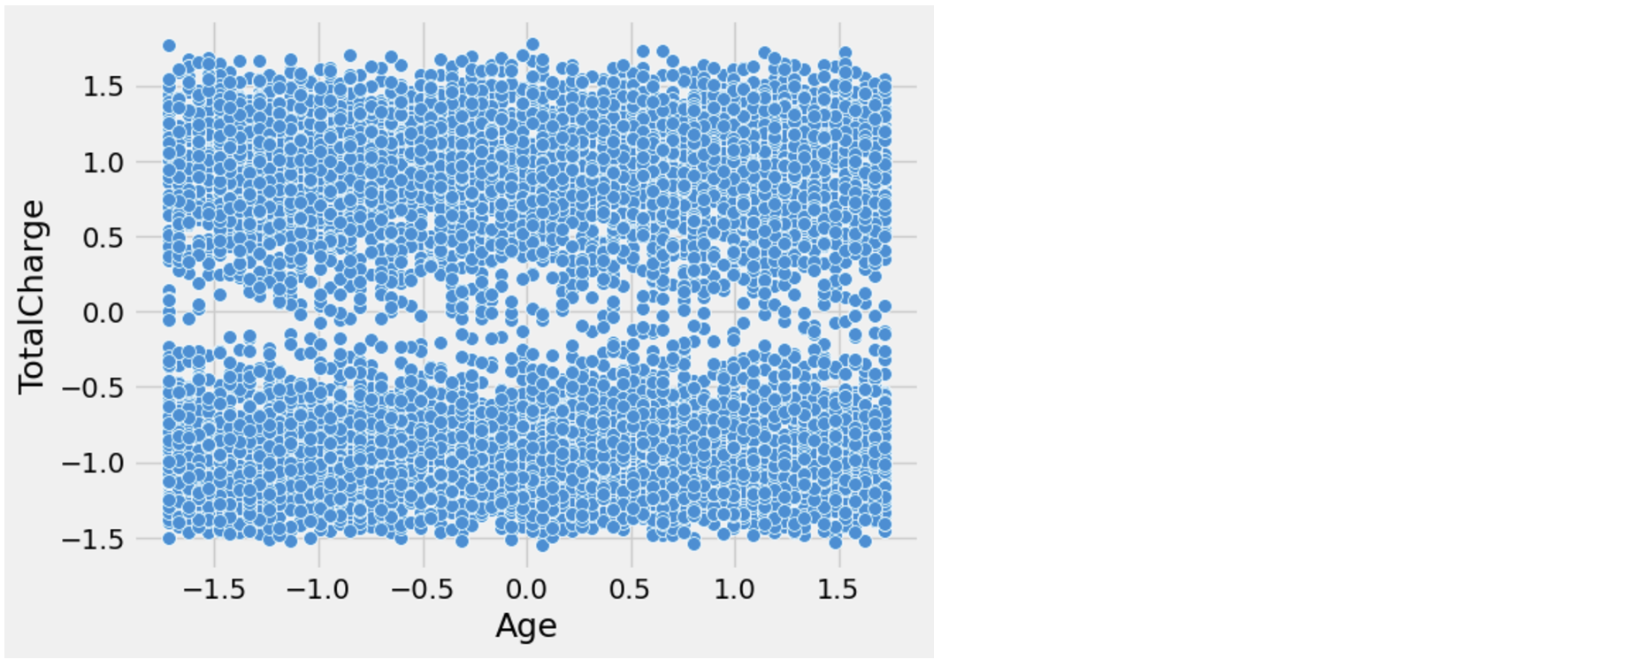

1. Evaluate Initial Model:

* Step: Evaluate the initial clustering model by examining the cluster distribution, calculating the centroids, calculating the silhouette score and creating a scatterplot with centroid visualization.
* Reason: This helps in assessing the preliminary results and understanding the basic structure of the data.

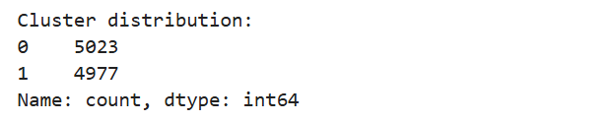 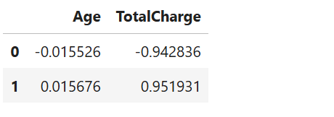

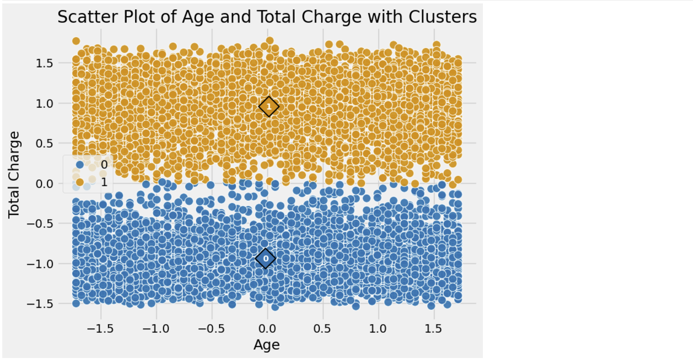 

The data points are nearly evenly distributed between the two clusters: Cluster 0 is 5023 data points and Cluster 1- 4977 data points. The centroids indicate the mean position of the data points within each cluster, showing the central tendency of the clusters.

The Silouette Score of 0.4498 indicates that the data points are fairly well-clustered, with an average level of cohesion and separation. However, a score below 0.5 suggests that there might be room for improvement in the clustering quality. Some points may be on the boundary between clusters, leading to less distinct separation.

From the scatter plot, the clusters are well-separated along the TotalCharge axis. Cluster 0 primarily occupies the lower half of the plot with negative TotalCharge values, while Cluster 1 occupies the upper half with positive TotalCharge values. Both clusters have a dense distribution of data points around their respective centroids, indicating high similarity among the data points within each cluster. The Age variable shows less variation compared to TotalCharge, suggesting that TotalCharge is a stronger differentiating factor for the clusters. The dense packing suggests that there might be subgroups or more nuanced patterns within the current clusters that a two-cluster model does not fully capture.

1. Elbow Plot and Silhouette Method (using the code provided by Dr. Kamara (*Panopto*, n.d.-b)):

* Step: Construct an elbow plot and use the silhouette method to determine the optimal number of clusters.
* Reason: The elbow plot helps identify the point where adding more clusters doesn’t significantly improve the model (the “elbow”), and the silhouette method measures how similar each point is to its own cluster compared to other clusters. These combined methods provide a more data-driven approach to selecting the optimal k.

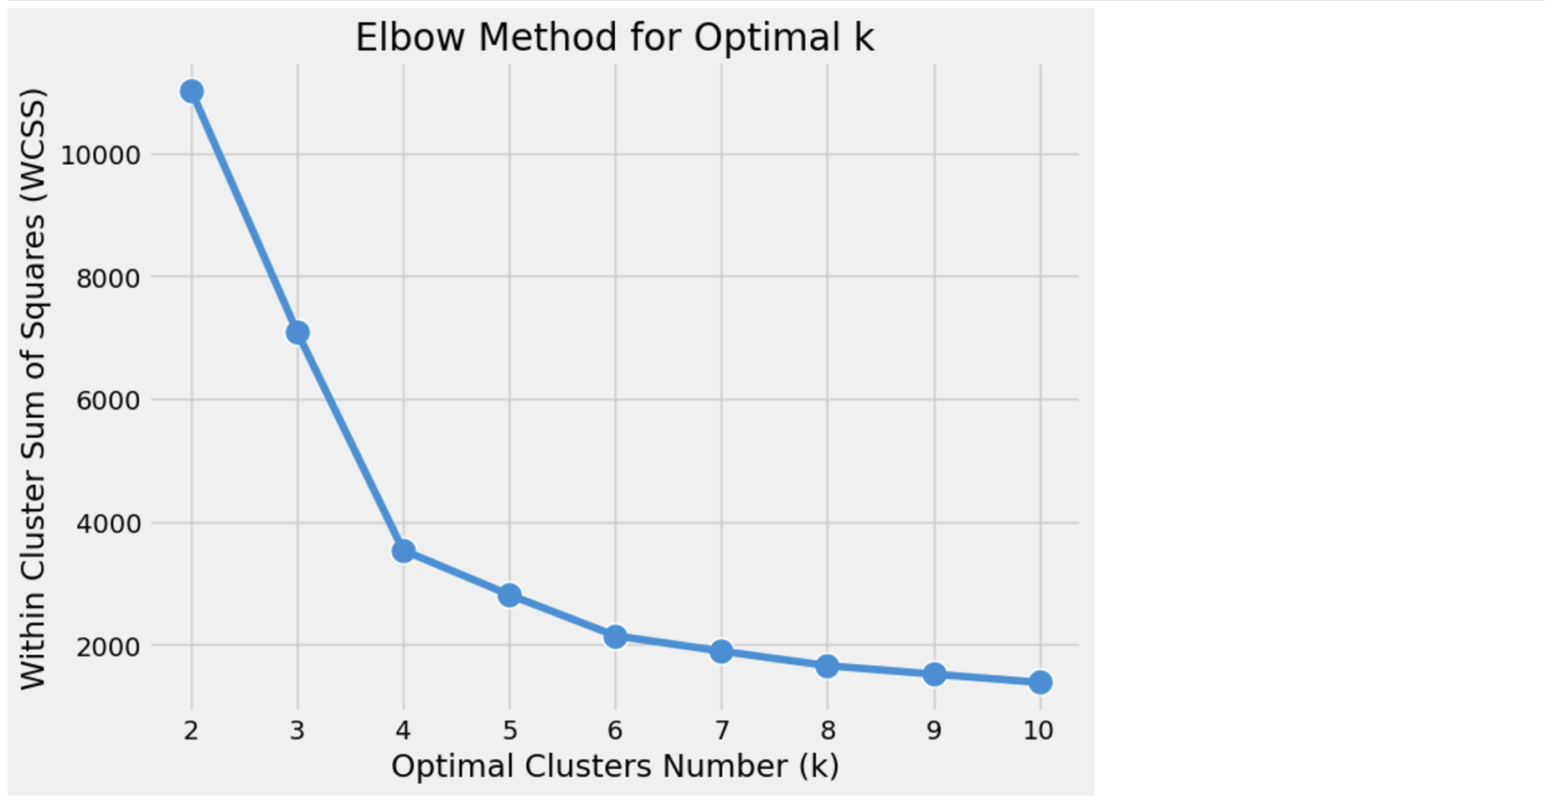

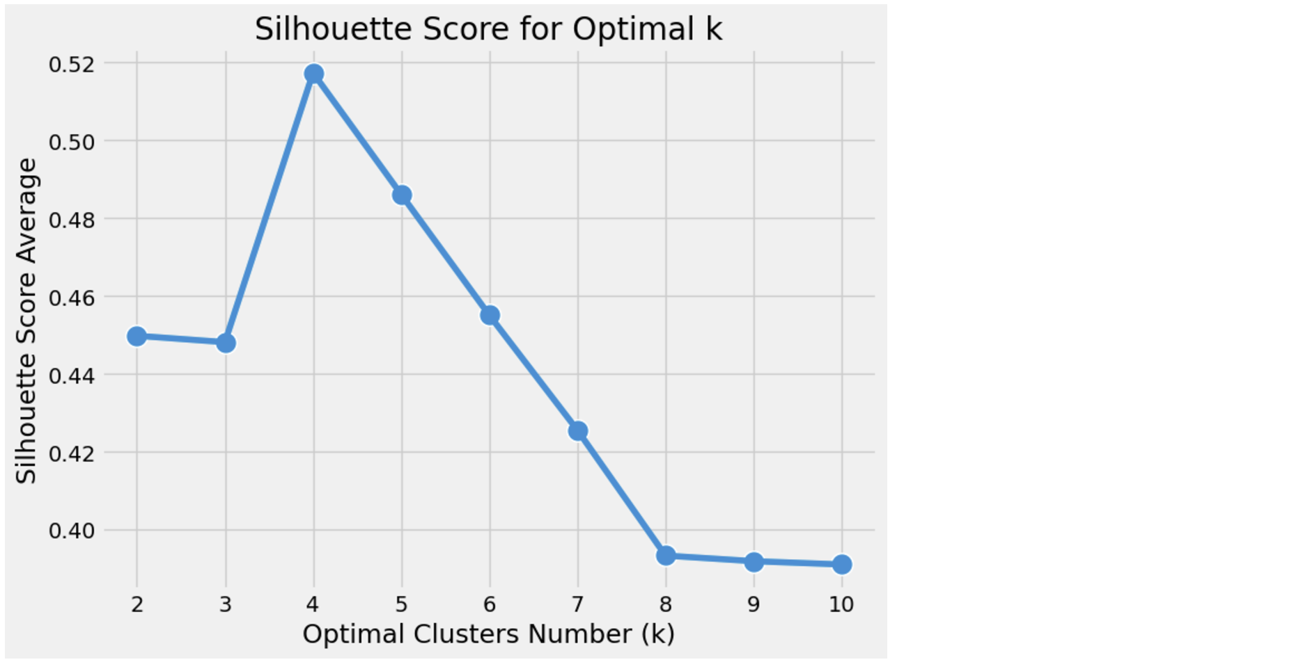

Based on the elbow and silhouette methods, the optimal number of clusters k is 4.

1. Re-run K-Means Clustering with k=4, visualize the final clusters and centroids, and calculate the silhouette score and final inertia.

* Step: Re-run the K-means clustering model with the updated k value determined by the elbow plot and silhouette method.
* Reason: This ensures that the selected number of clusters best fits the underlying data structure, leading to more accurate and meaningful clusters.

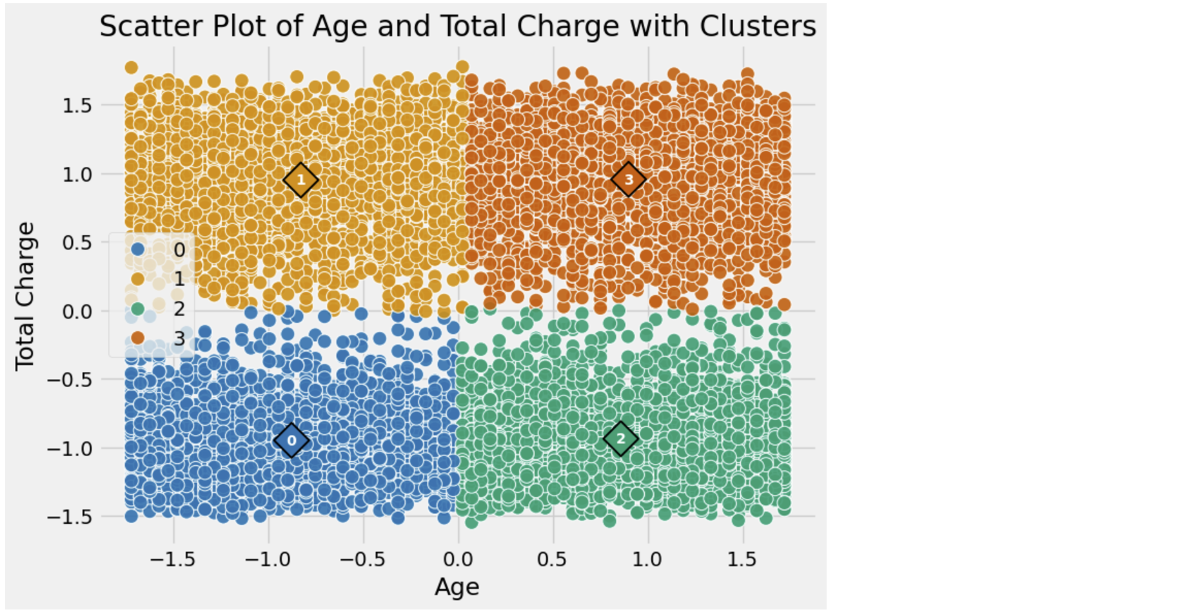

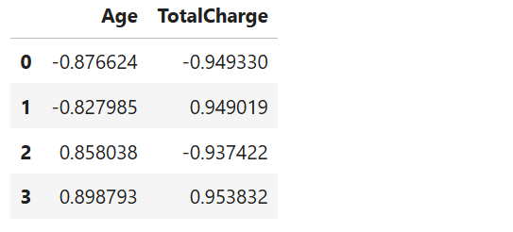 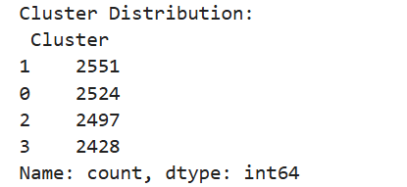

 

**D. 2.** Please see **D212_task1.py** file with annotated code attached.



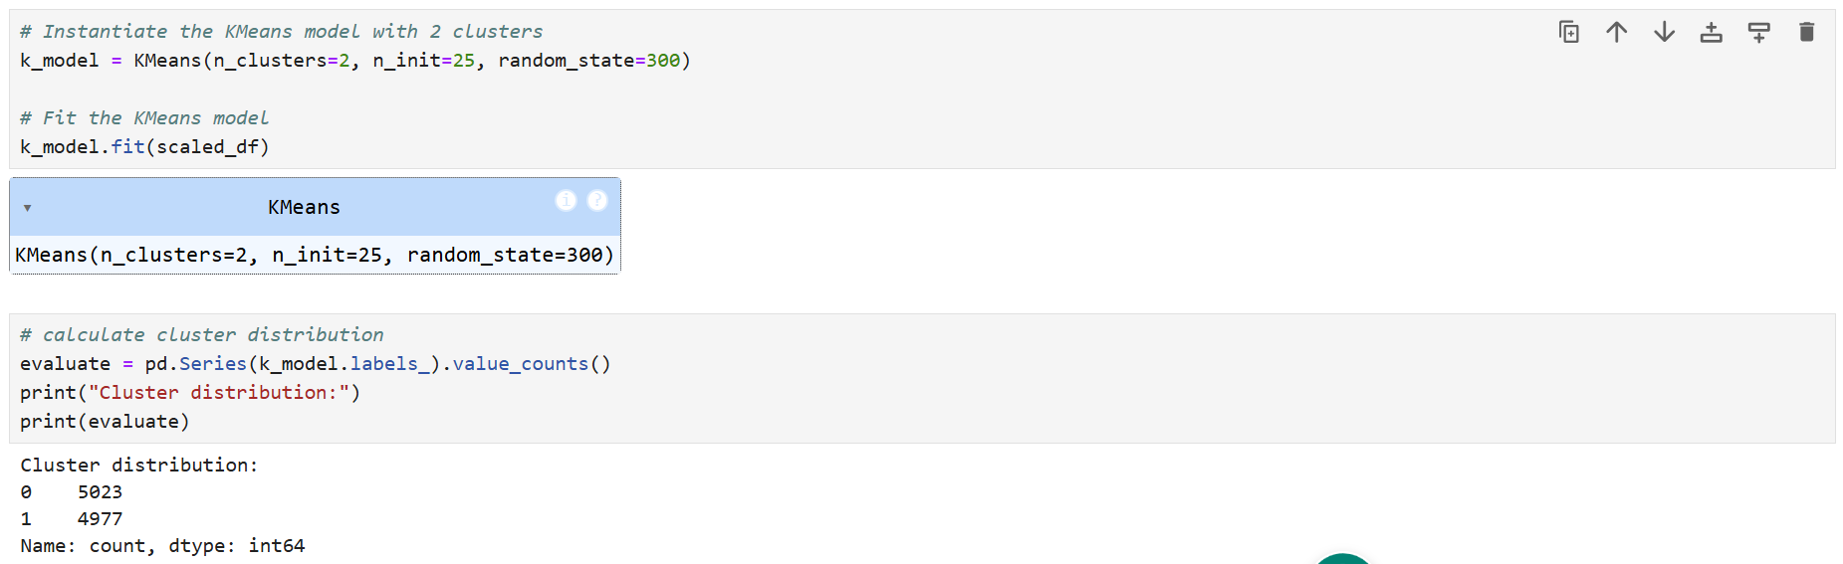

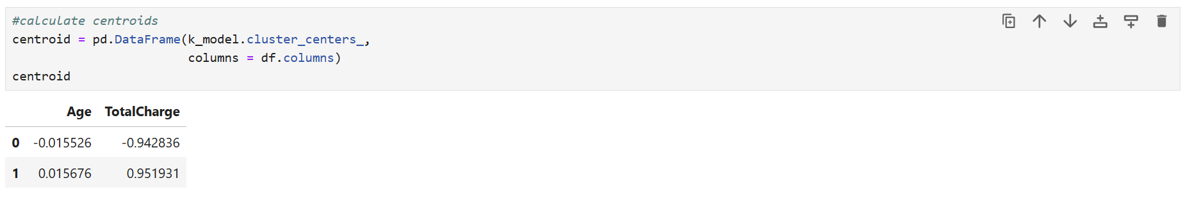

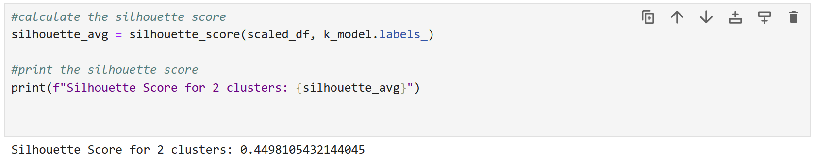

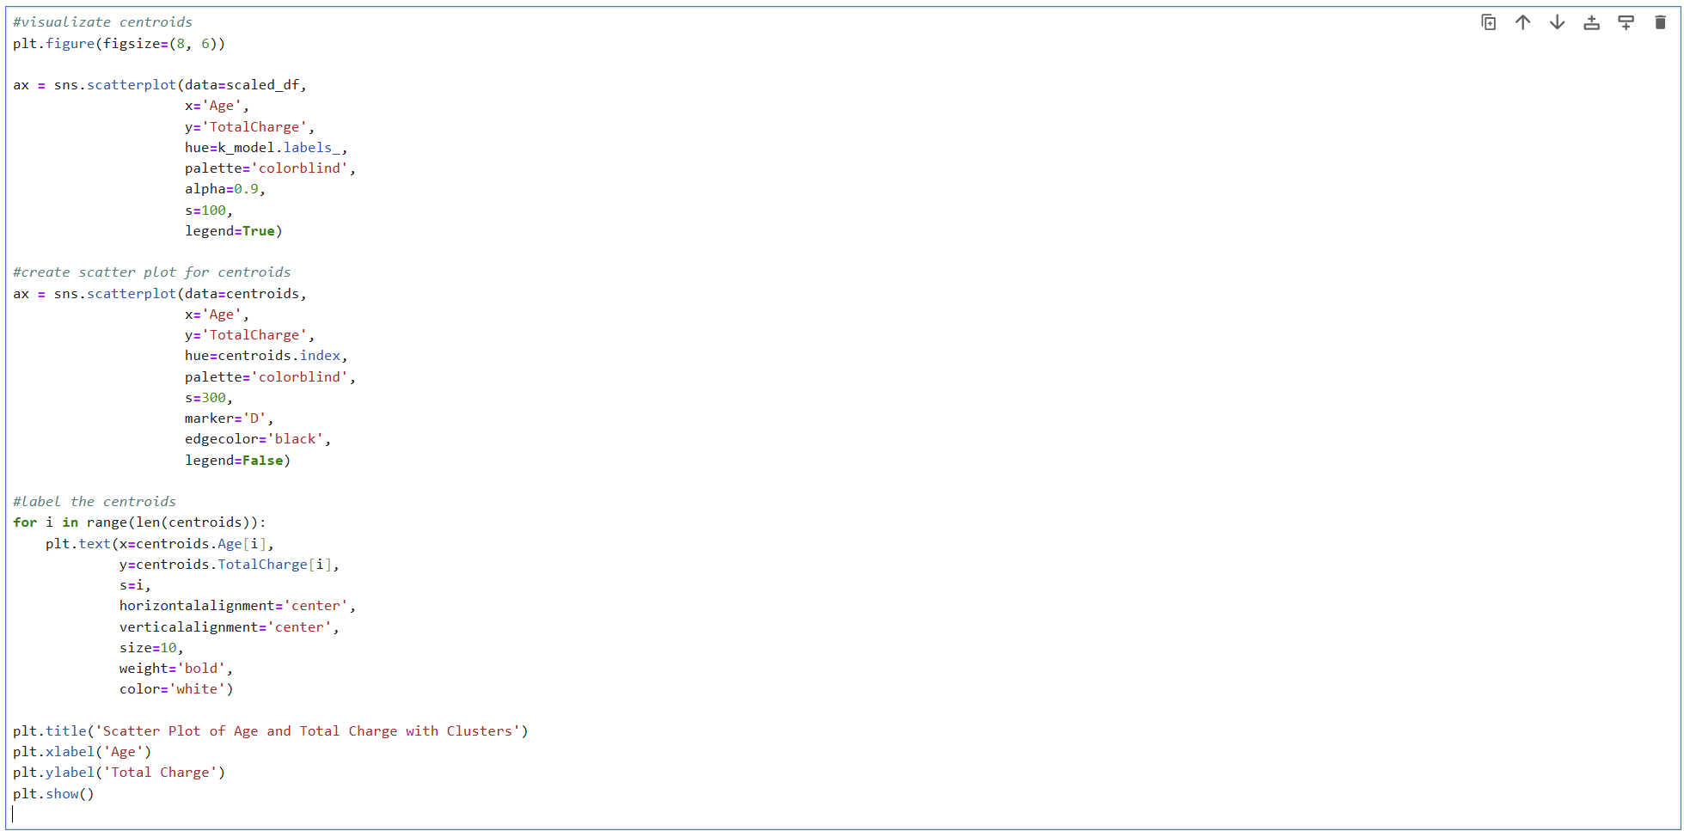

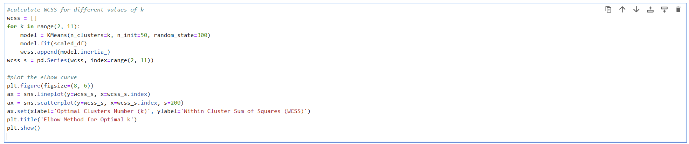

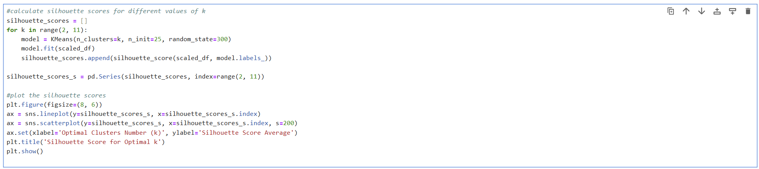

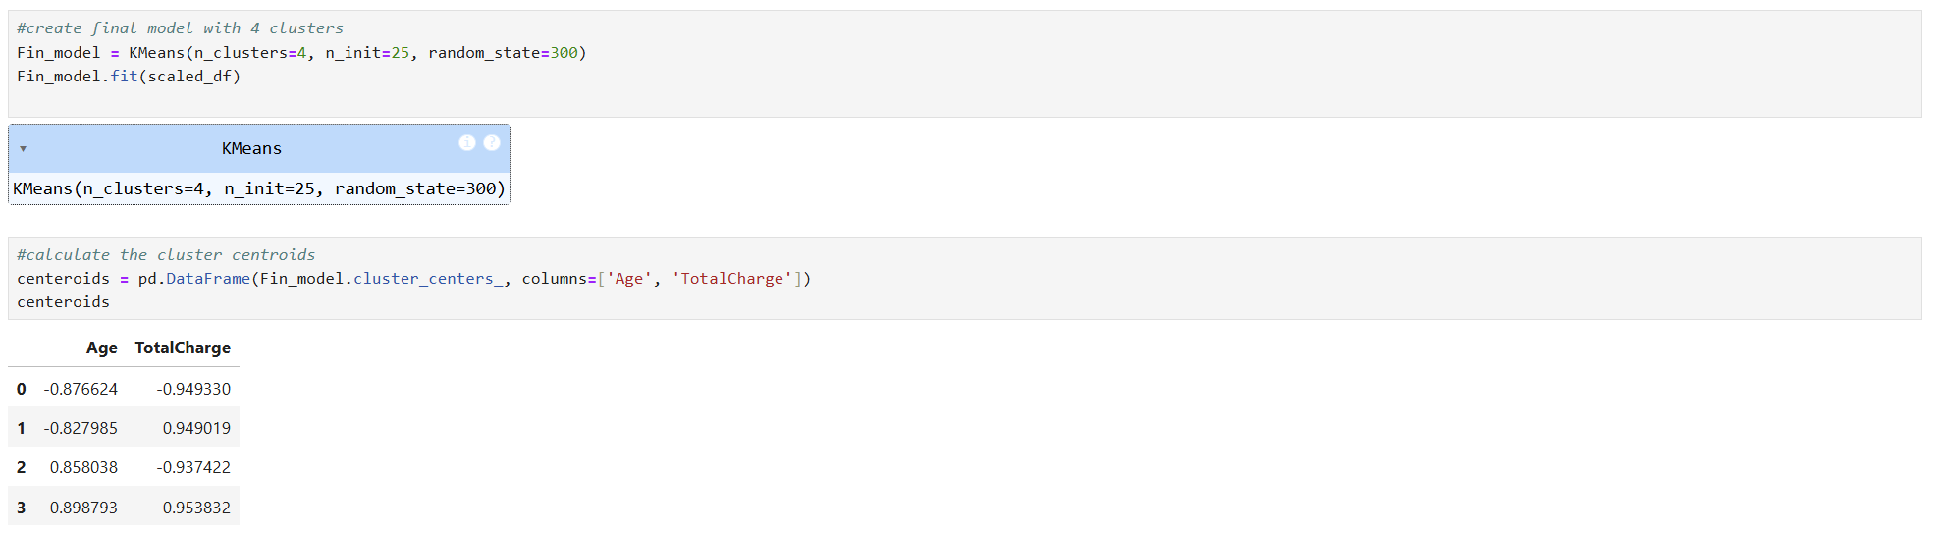

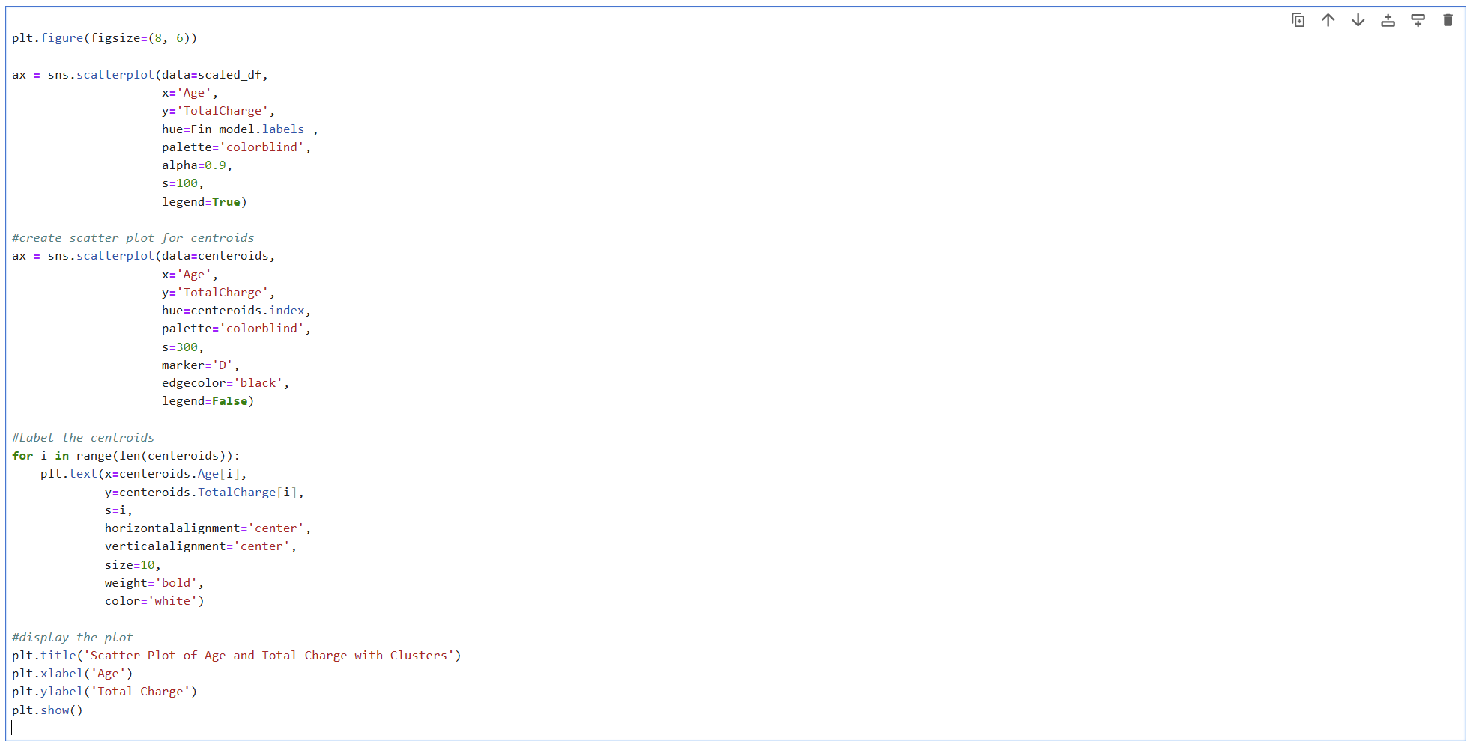

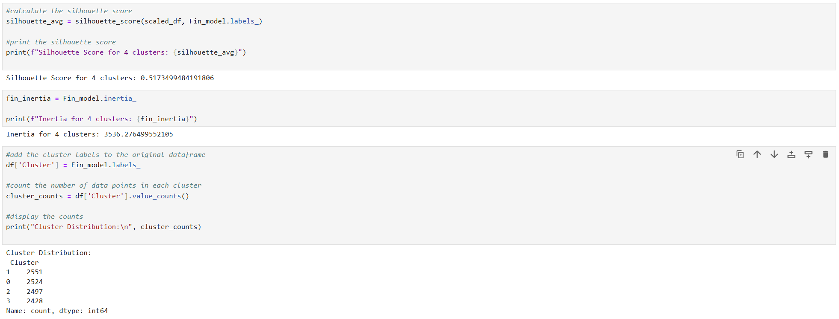

**Part V: Data Summary and Implications**

**E. 1.** The quality of the clusters can be evaluated using the silhouette score and cluster inertia. The silhouette score for the 4-cluster model is 0.5173. The increase in the silhouette score from 0.4498 to 0.5173 demonstrates an improvement in clustering quality. The four-cluster model provides better-defined and more meaningful groupings of the data points. A silhouette score above 0.5 indicates that the clusters are reasonably well-defined, with points closer to their own cluster than to other clusters. This suggests that the clusters are distinct and well-separated. The inertia for the 4-cluster model is 3536.28. Inertia measures the sum of squared distances of samples to their closest cluster center. Lower values indicate better-defined clusters. The obtained inertia value suggests that the clusters are tightly clustered around their centroids. The cluster distribution is fairly balanced, with each cluster containing around 2400 to 2550 data points, ensuring that no single cluster dominates the dataset.

**E. 2.** The scatterplot showcases data points categorized into four distinct clusters, labeled 0, 1, 2, and 3.

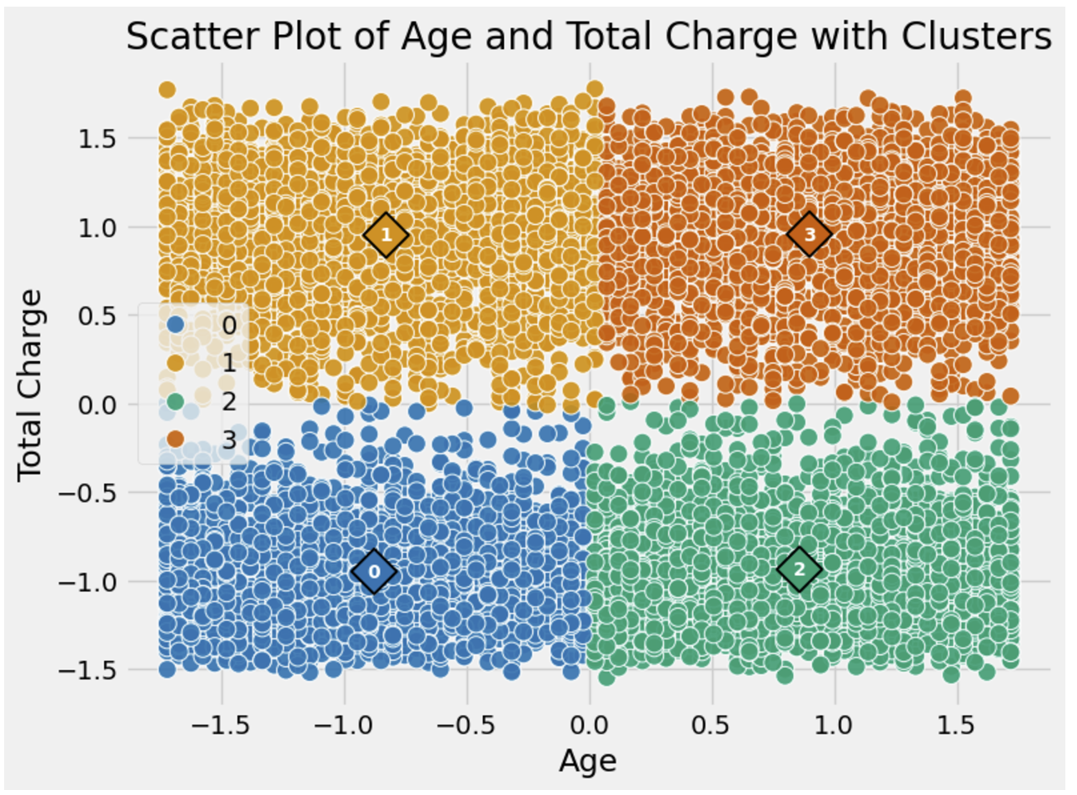

* Cluster 0 (blue) has a centroid at approximately (-0.88, -0.95) and occupies the lower left quadrant, indicating lower TotalCharge and a range of Age.
* Cluster 1 (orange) has a centroid at approximately (0.90, 0.95) and is situated in the upper right quadrant, indicating higher TotalCharge and a range of Age.
* Cluster 2 (green) has a centroid at approximately (-0.83, 0.95) and is found in the lower right quadrant, indicating higher Age and lower TotalCharge.
* Cluster 3 (brown) has a centroid at approximately (0.86, -0.94) and is located in the upper left quadrant, indicating higher Age and higher TotalCharge.

This scatterplot with centroids indicates clear separation between clusters, primarily driven by the “TotalCharge” variable. The clusters are visually distinct, with minimal overlap. This clear separation suggests that the K-means algorithm effectively identified meaningful groupings within the data. The clusters show variation along both the Age and TotalCharge axes. Clusters 0 and 2 are associated with lower TotalCharge, while Clusters 1 and 3 are associated with higher TotalCharge. The Age axis shows that Clusters 0 and 3 include higher Age values, while Clusters 1 and 2 include lower Age values. The data points are relatively evenly distributed among the four clusters, with counts ranging from 2428 to 2551. This balanced distribution indicates that the clustering process did not create disproportionately large or small clusters.

**Implications:**

* Resource allocation: The hospital can tailor its resource allocation based on the clusters. For instance, clusters with higher TotalCharge may indicate patients requiring more intensive or costly treatments.
* Targeted interventions: Different clusters might represent different patient demographics or conditions. Personalized interventions can be developed for each cluster to improve patient outcomes and satisfaction.
* Cost management: Understanding the distribution of TotalCharge across clusters can help the hospital in managing costs and negotiating prices for services.

**E. 3.** One limitation of this data analysis is the reliance on only two variables (`Age` and `TotalCharge`). While these variables provide valuable insights, incorporating additional factors such as medical history, treatment types, and length of stay could offer a more comprehensive understanding of patient clusters. Additionally, the assumption that clusters are spherical and of similar size (a limitation of K-means) may not always hold true, potentially leading to suboptimal clustering results for non-spherical data distributions.

**E. 4.** Based on the clustering analysis, I recommend the following course of action for the real-world organizational situation:

* Implement personalized care plans: Develop and implement care plans tailored to each cluster’s characteristics. For instance, clusters with higher `TotalCharge` should receive more focused medical attention and resource allocation.
* Optimize resource allocation: Use cluster information to allocate hospital resources more efficiently. Ensure that clusters with higher needs receive appropriate staffing, equipment, and facilities.
* Monitor and adjust strategies: Continuously monitor the performance and outcomes of patients within each cluster. Use the insights to refine and adjust treatment strategies, aiming for improved patient outcomes and cost efficiency.
* Incorporate additional variables: To enhance future clustering analyses, consider incorporating additional variables such as patient medical history, types of treatments received, and length of hospital stay. This will provide a more holistic view of patient segmentation and needs.

These steps will help the hospital better manage patient care, optimize costs, and improve overall efficiency based on the insights derived from the clustering analysis.

**Part VI:**

**F.** Here is the link to the demonstration video: [https://wgu.hosted.panopto.com/Panopto/Pages/Viewer.aspx?id=0a2ca7b3-9aea-45e1-8e52-b23f00075e0a#](https://wgu.hosted.panopto.com/Panopto/Pages/Viewer.aspx?id=0a2ca7b3-9aea-45e1-8e52-b23f00075e0a)

**G.** Code References:

*Panopto*. (n.d.-a). Panopto. <https://wgu.hosted.panopto.com/Panopto/Pages/Viewer.aspx?id=8048d616-4d5f-4625-accd-b0ee01873eba>

*Panopto*. (n.d.-b). Panopto. <https://wgu.hosted.panopto.com/Panopto/Pages/Viewer.aspx?id=9fa8783e-d7d2-4b4d-b06e-b0ee01874bea>

**H.** Sources:

Ankita. (2024, October 17). *K-Means: getting the optimal number of clusters*. Analytics Vidhya. https://www.analyticsvidhya.com/blog/2021/05/k-mean-getting-the-optimal-number-of-clusters/

*Data Mining II*. (n.d.). [Video]. datacamp.com. Retrieved December 1, 2024, from https://app.datacamp.com/learn/custom-tracks/custom-data-mining-ii

GeeksforGeeks. (2023, December 9). *Demonstration of KMEANs assumptions*. GeeksforGeeks. https://www.geeksforgeeks.org/demonstration-of-k-means-assumptions/

*Panopto*. (n.d.-a). Panopto. https://wgu.hosted.panopto.com/Panopto/Pages/Viewer.aspx?id=8048d616-4d5f-4625-accd-b0ee01873eba

*Panopto*. (n.d.-b). Panopto. https://wgu.hosted.panopto.com/Panopto/Pages/Viewer.aspx?id=9fa8783e-d7d2-4b4d-b06e-b0ee01874bea

*Panopto*. (n.d.-c). Panopto. https://wgu.hosted.panopto.com/Panopto/Pages/Viewer.aspx?id=3fe13831-fe4b-4c6b-a3eb-b0ee018754bc

*Python cheat sheet for beginners*. (n.d.). datacamp.com. Retrieved December 2, 2024, from https://www.datacamp.com/cheat-sheet/getting-started-with-python-cheat-sheet

Sharma, P. (2024a, November 29). *An introduction to K-Means clustering*. Analytics Vidhya. https://www.analyticsvidhya.com/blog/2019/08/comprehensive-guide-k-means-clustering/